Unit 2 Lab and Data Overview

Corey Crooks
Purdue University Global
IT331-01
Ahmed Banafa
November 23, 2022
Section 1: Screenshots
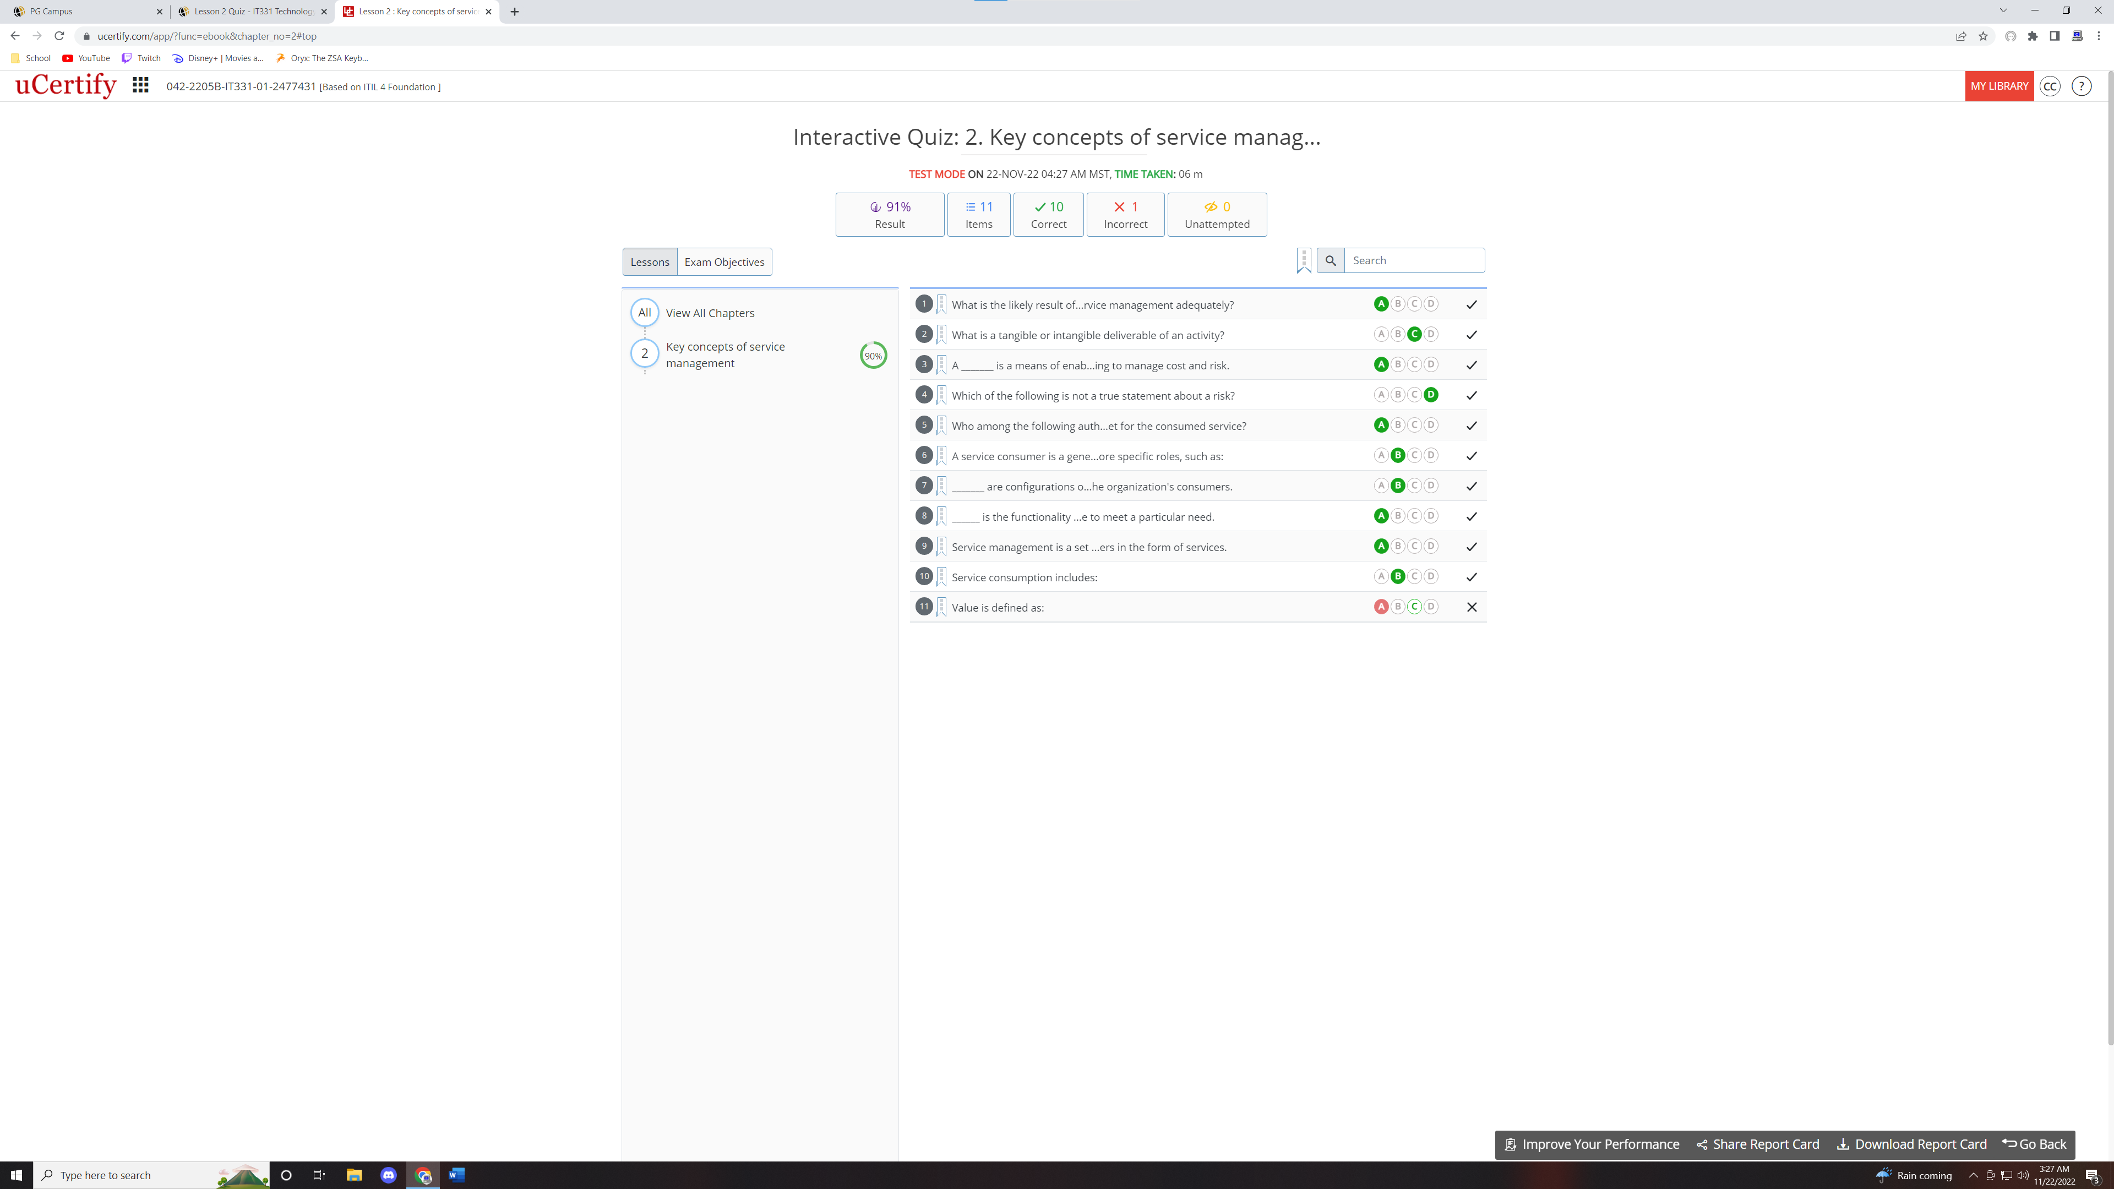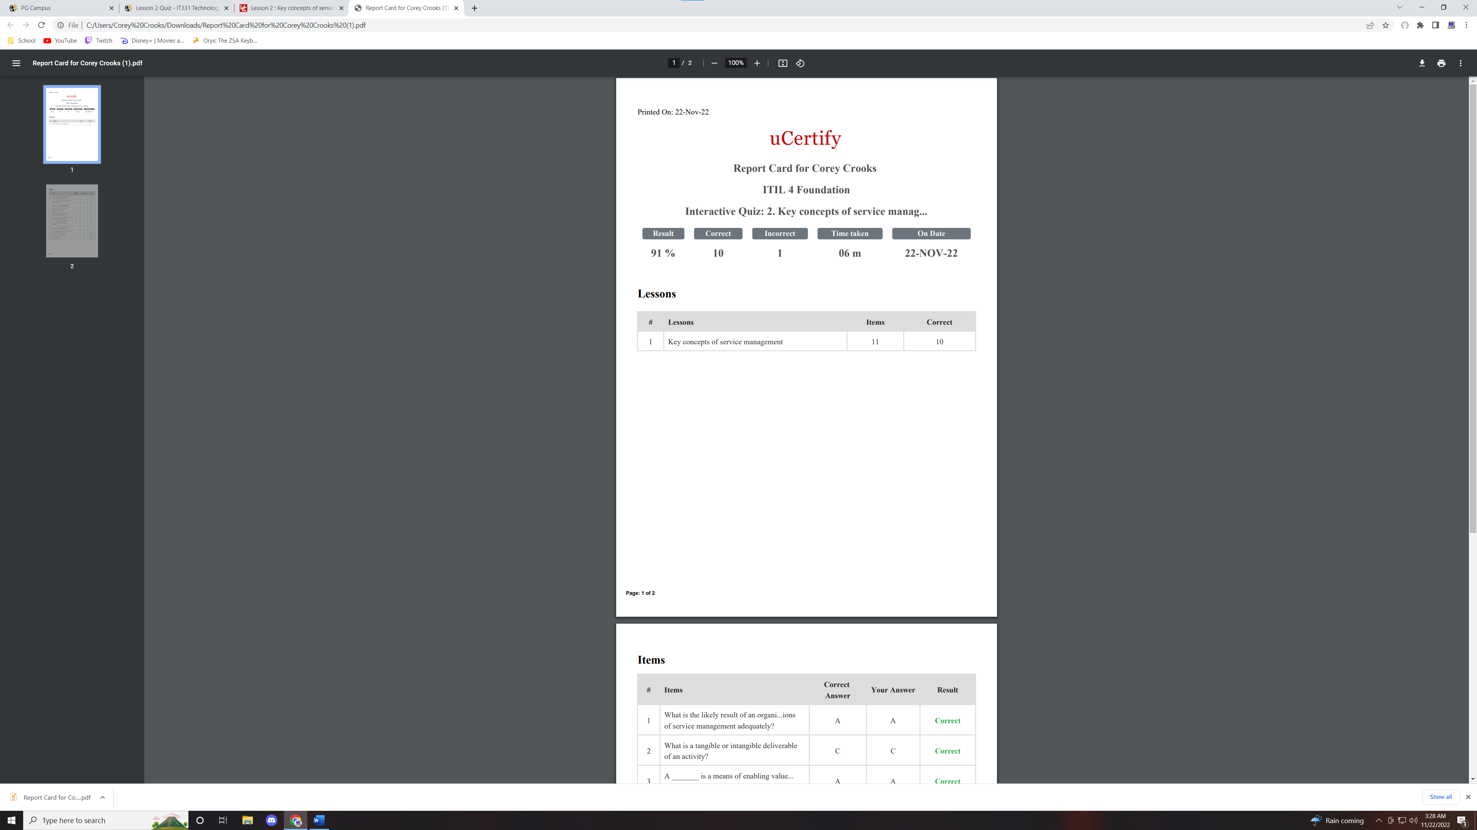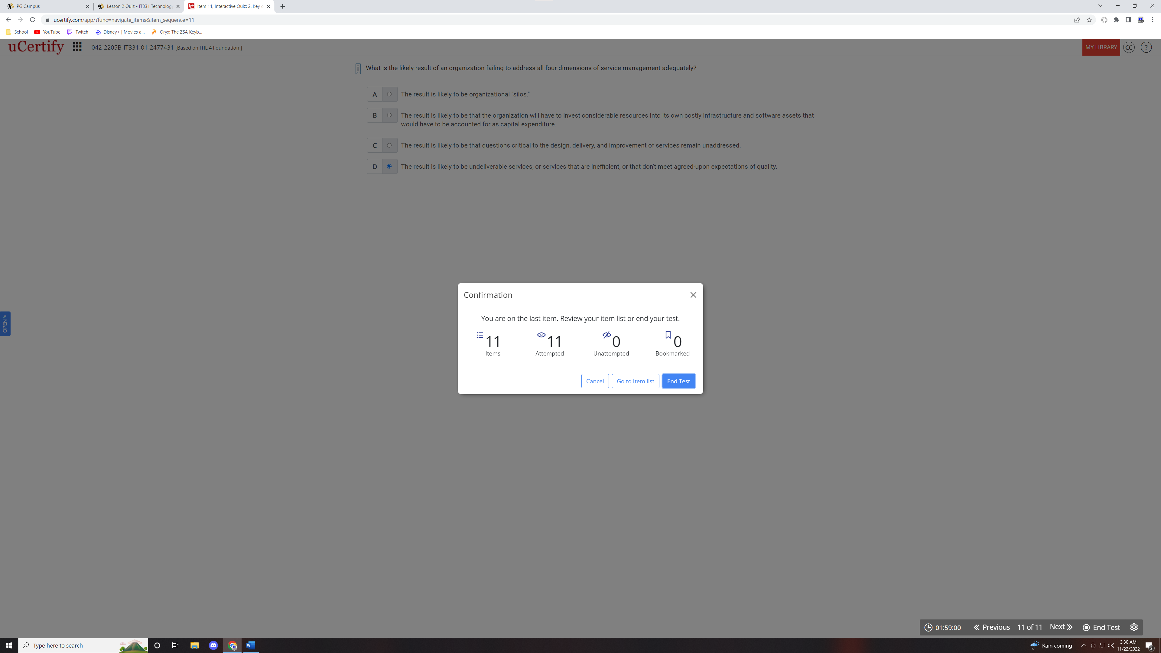
Section 2: Writing
- If you connected your laptop to a wireless hotspot, opened your email program and sent an email to someone, what connections would you make? Describe the series of connections that would be made, the equipment you would use for the wireless hotspot, the protocols which would be used and the TCP/IP layers which the email would go through.
  - Let’s explain the connections required to send an email in a step-by-step process. Firstly, you would arrive at the café to send an email to your coworker in order to explain that you are currently stuck in traffic, and might be 20 minutes late to your shift today. You open your laptop, and connect to the Café’s WiFi hotspot. Depending on the Operating System you’ve used, you may already have made a number of connections already. Firstly, you would need to log into the hotspot itself using your laptop computer. Secondly, you would need to log into the account on your laptop. This usually requires server authentication should you be using an OS X (Apple, 2022), or an Apple Device, or Windows device (Microsoft, 2021). Next, you’re going to open your email program. For this example, we will use Outlook. You will need to authenticate your Outlook account with the Microsoft servers. Once logged in, Outlook will store incoming messages using the POP 3 or IMAP protocols depending on how you set up your account. Sending your email will require the Simple Mail Transport Protocol in order to deliver your email to the intended recipient (Timmermans, 2016).

- The addition of control information to a packet as it moves through the layers is called encapsulation. Provide a brief overview of the process that requested pieces of data (packets) undergo as it is sent over the Internet. Include the difference between the size of a typical packet and the size of a typical Ethernet frame?
  - Data Encapsulation has a number of aspects to it, so here is a brief explanation on its simple concepts. When data is requested from a client, it is encapsulated into packets. The packets contain both a header, and payload in order to provide structure to the information. The Header contains delivery information such as origin, destination, and important delivery instructions while the payload contains the requested data to be delivered. As the packet is processed from one data layer to another, more and more delivery instructions are added onto it in order to provide instructions for that specific layer upon delivery. When a layer is finished with its instructions, the packet is handed up one layer in which case the header data from the previous layer becomes part of the payload for the next layer. This gives the name “Encapsulation”. When the information is delivered, the encapsulation is reversed in order to properly be delivered through the payload stack. Packets can range in size based on different types. For instance, a UDP packet mainly consists of 108 bytes while an IP packet consists of 128 bytes. An Ethernet frame on the other hand contains additional information in its header relating to delivery information, and frame checksums. The payload of an Ethernet frame is the IP packet, while the IP Packet’s payload is the UDP packet (Clemson University, n.d.). Thus, many layers’ protocols have come together and been organized into the data to be delivered and read by the receiving machine.

- Define data communication? Briefly discuss how signals are clocked, include what is meant when a signal is self-clocking and how does the way in which signals are clocked affect data transmission? What is the relationship between frequency and Baud Rate?
  - As put by Symmetry Electronics, “…a clock signal as a particular type of signal that oscillates between a high and a low state. The signal acts like a metronome, which the digital circuit follows in time to coordinate its sequence of actions” (Wojciechowicz, 2018). A clock system in digital electronics ensures that operations are done in a timely manor, and schedules are executed properly. These clocks can help the system run with a higher efficacy overall. Clocks are produced by a current running through quartz crystal, or commonly referred to as a crystal resonator. The quartz is precisely cut in order to regulate the frequency of osciliations produced from the crystal. Due to this precision, the crystal must operate specifically at this frequency (Wojciechowicz, 2018). Baud rate can be used to determine the number of Bits Per Second a machine may be sending out using the formula “bits per second = baud * bits per baud” (University of Delaware, n.d.). Because of this relationship, Baud rate is measured using frequency behavior.
- Provide the results of these calculations:
  - What is the frequency, in Hertz, of a signal that repeats 60,000 times within one minute? What is its period (the length of one complete cycle)?
    - The frequency of a signal measured in Hertz = “Cycles” / “Seconds” (ADinstruments, n.d.). Using this formula, we can gather that Hertz = “60,000” / “60”, or Hertz = 1000.
  - What is the bandwidth of a signal composed of frequencies from 60 Hz to 600 Hz?
    - The formula for determining the bandwidth of a signal composition is as such: Bandwidth = “Highest Signal Hz” – “Lowest Signal Hz” (Federation of American Scientists, n.d.). Thus, we can gather Bandwidth = “600 Hz” – “60Hz”, or Bandwidth = 540 Hz.

References
ADinstruments. (n.d.). How do I calculate the time interval if I know the frequency? Retrieved from ADinstruments: https://www.adinstruments.com/support/knowledge-base/how-do-i-calculate-time-interval-if-i-know-frequency#:~:text=Frequency%20is%20expressed%20in%20Hz%20(Frequency%20%3D%20cycles%2Fseconds).
Apple. (2022). Join your Mac to a network account server. Retrieved from support.apple.com: https://support.apple.com/guide/mac-help/join-your-mac-to-a-network-account-server-mh27627/mac
Clemson University. (n.d.). Packets and Encapsulation. Retrieved from clemson.edu: https://www.cs.clemson.edu/course/cpsc424/material/TCP-IP%20Networks/Packets%20and%20Encapsulation.pdf
Federation of American Scientists. (n.d.). Amplitutde Modulation. Retrieved from man.fas.org: https://man.fas.org/dod-101/navy/docs/es310/AM.htm
Microsoft. (2021, July 29). Windows Authentication Overview. Retrieved from learn.microsoft.com: https://learn.microsoft.com/en-us/windows-server/security/windows-authentication/windows-authentication-overview
Timmermans, K. (2016, July 17). Understanding Email Protocols (POP, Imap, MAPI, EAS, Exchange). Retrieved from contactgenie.info: https://contactgenie.info/understanding-email-protocols-pop-imap-mapi-eas/
University of Delaware. (n.d.). Bauds and Bits. Retrieved from physics.udel.edu: https://www.physics.udel.edu/~watson/scen103/projects/96s/thosguys/baud.html
Wojciechowicz, T. (2018, June 19). What Are Clock Signals in Digital Circuits, and How Are They Produced? Retrieved from Symmetry Electronics: https://www.symmetryelectronics.com/blog/what-are-clock-signals-in-digital-circuits-and-how-are-they-produced-symmetry-blog/

